

Home Learning Overview
September 2023

Weekly Homework
All children should come to school with a suitable book bag or backpack. Every week, children should be given the homework outlined below.
Nursery
- A book for pleasure chosen by the child with a zippy bag/story bag to go with them (from Monday to Friday)
- A Rainbow Reading Booklet to share views on the book
F2
- A library book to read for enjoyment
- A Little Wandle phonics reading book or access to an eBook online to support their journey in learning to read. Children will receive their first reading book when they can confidently blend the sounds to read the words and recognise all the graphemes in that book.
- A Reading Diary to record when a child reads
- A communication wallet with any key information in
- Phonics flashcards – relevant to phase they are on/words they are struggling with if they need them
KS1
- A Reading Diary to record when a child reads
- A reading book that matches your child’s phonic knowledge or access to an eBook online to support their journey in learning to read
- A book for enjoyment
- A communication wallet with any key information in
- Phonics flashcards – relevant to phase they are on/words they are struggling with if they need them
- Numbots passwords (log on at least once a week)
- A termly topic homework bingo grid filled with fun activities related to what they children are learning that term. Full completion of the grid lets the children go to gold on our chart!
KS2
- A Reading Diary to record when a child reads
- A reading book/library book
- Each week your child will be assigned tasks on Spelling Shed relating to a spelling pattern they will be tested on.
- TTRS passwords (log on at least once a week)
- A termly topic homework bingo grid filled with fun activities related to what they children are learning that term. Full completion of the grid lets the children go to gold on our chart!

Rewards
Children should not be sanctioned for not completing the homework but they can be rewarded for completing it consistently. Rewards include:
- TTRS/Numbot star of the week
- Reader of the week
- Star of the week
- It can inform your judgement on ‘Always Milford’ rewards
- Individual class rewards.
- Termly topic homework completion leads to gold on our chart

Termly Topic Homework

At the start of each term, children in KS1/KS2 will be given a selection of homework activities related to the learning that term. It should include a range of activities from across the curriculum and they can relate to the overarching topic that term, where possible.

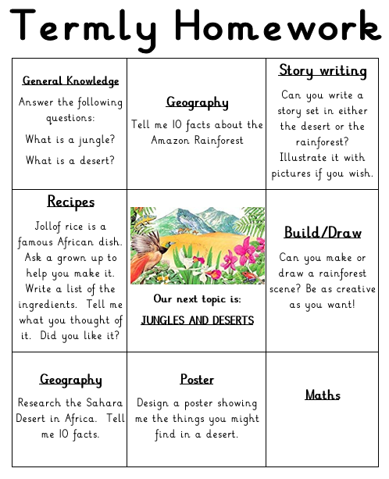

They will have the term to complete the activities. A fully complete grid leads to gold and a partially completed grid leads to bronze/silver. Teacher discretion can be applied here.

