

THE MILFORD ACADEMY

KS1 WRITTEN CALCULATION POLICY

February 2025
Lorren Brennan

General statement
The purpose of this calculation policy is to ensure there is a consistent and concise approach to the delivery of key arithmetic skills throughout Milford Primary School. This document clearly outlines, with examples, how to support children with their written calculations. CPD will be provided to staff annually on these key skills and to ensure staff are fluent in these key mathematical concepts which underpin the rest of the maths curriculum. It will support children’s fluency if staff are consistent in their approaches to teaching these key concepts.

Non-Negotiables
For EYFS, the staff will manage floor books for maths work they feel appropriate to record. In KS1, both staff and pupils need to have high expectations of the presentation and layout in the workbooks. Presentation expectations need to be consistent:

- Margins: They need to be 2 full squares wide on squared paper. In year 1, children are not expected to draw margins in their books, this begins in year 2.
- Date & LO: In Year 1, it will be to the teachers discretion if the children should or should not write the date and lesson objective or if this will be typed and stuck in by the teacher. In Year 2, children are expected to write them – as per the maths policy – from January onwards. There may be some exceptions to this depending on the individual child.
- Handwriting: On squared paper, children should put one number per square. However, when writing, children should use their normal handwriting (they should not put one letter per square). When using plain paper, this is not relevant. Handwriting and number formation should be accurate and of a high quality.



Addition & Subtraction at Milford
EYFS | Year 1 | Year 2
Understand the cardinal value of number words, for example understanding that ‘four’ relates to 4 objects.  Subitise for up to to 5 items.  Automatically show a given number using fingers.  Devise and record number stories, using pictures, numbers and symbols (such as arrows). | 1AS–1 Compose/Represent numbers to 10 from 2 parts, and partition numbers to 10 into parts, including recognising odd and even numbers.  Number bonds within 20.  1AS–2 Read, write and interpret equations containing addition, subtraction and equals for numbers up to 20. | 2AS–1 Add and subtract across 10.  2AS–3 Add and subtract within 100 by applying related one-digit addition and subtraction facts  Add and subtract numbers within 100 using a scaffolded approach (practical, pictorial, number lines, column method using base 10 to begin with)

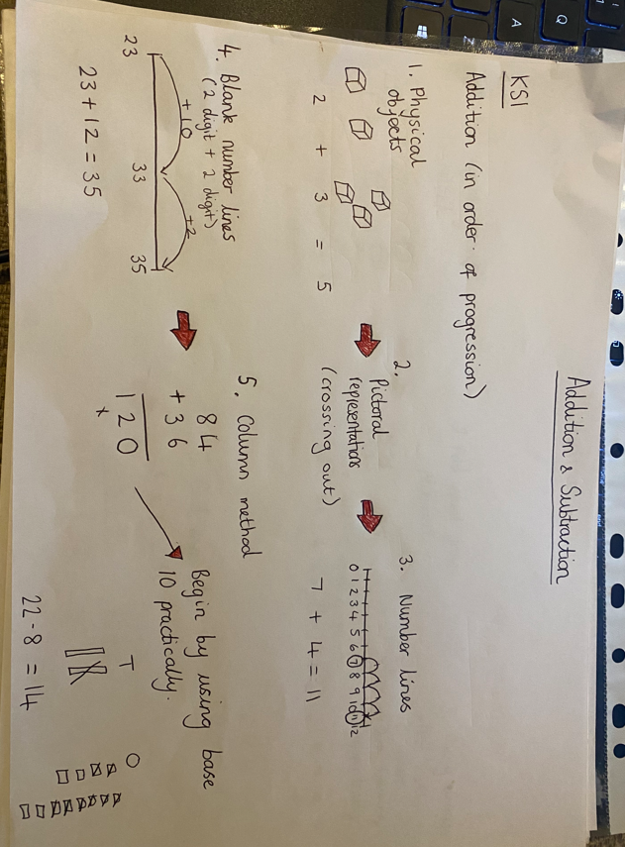



Multiplication & Division at Milford
EYFS | Year 1 | Year 2
Explore and understand vocabulary:  Ones, groups, sharing, lots of. | Explore multiplication as repeated addition using practical methods to begin with.  Use practical activities and manipulatives to explore grouping, sharing, lots of, groups of. | Recognise repeated addition contexts, representing them with multiplication equations and calculating the product, within the 2, 5 and 10 multiplication tables.  Explore the multiplication and division symbols. Practice reading, writing and saying them within number sentences.  Look at practical materials such as arrays and develop to mental methods of x tables.  Understand what is meant by inverse operations (missing factors).

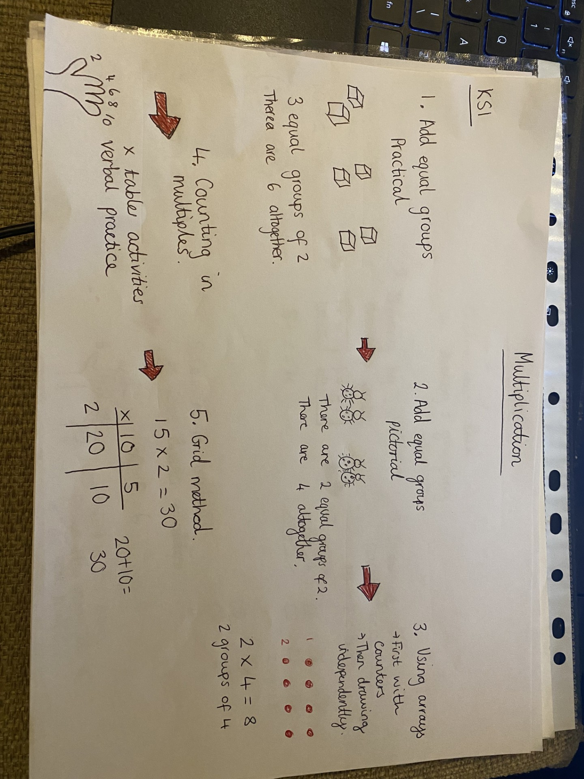
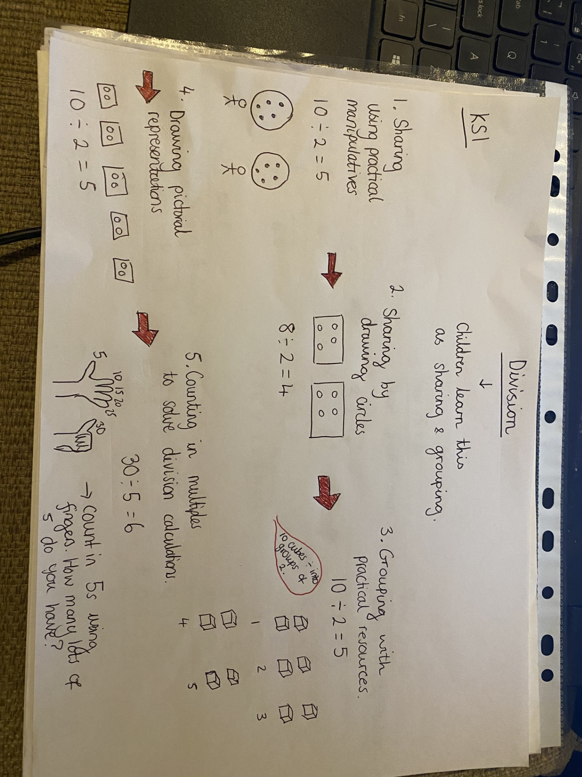
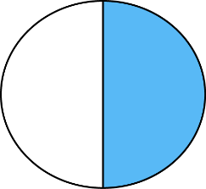


Fractions at Milford
EYFS | Year 1 | Year 2
 | Recognise, find and name a half as one of two equal parts of a quantity.  Recognise, find and name a quarter as one of four equal parts of a quantity. | Reason about the location of whole numbers in the linear number system.  Recognise, find, name + write fractions ( a third, a quarter, a half, two quarters and three quarters) of a set of objects of quantity. Link to sharing.



