

THE MILFORD ACADEMY

MATHEMATICS POLICY
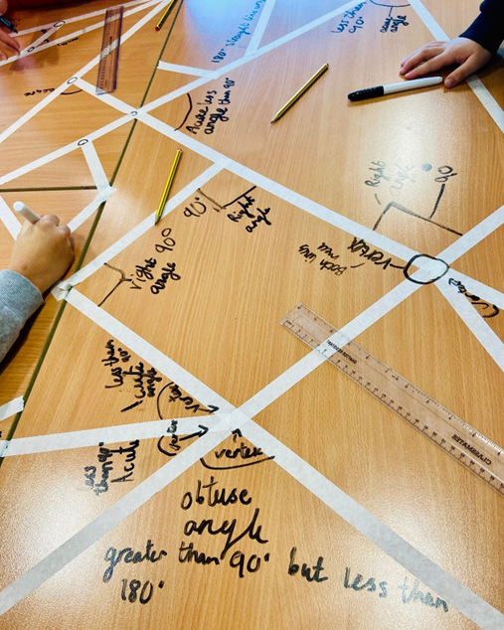
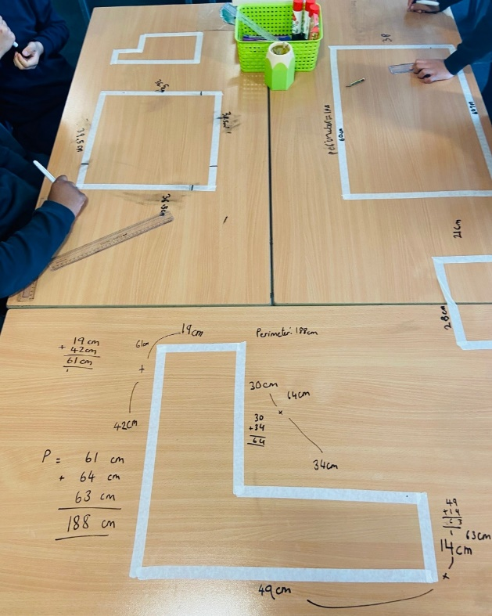
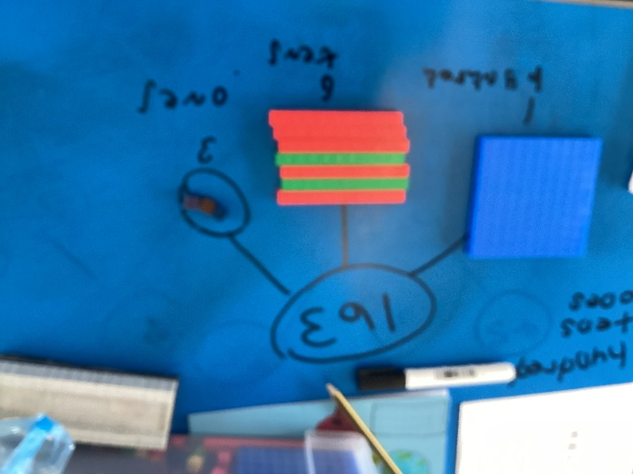

General Statement
We believe that mathematics is uniquely powerful in helping us to make sense of and describe our world. It is a fascinating subject, dealing with the nature of number, space, pattern and relationships - it is useful and creative. At The Milford Academy, we understand that children not only need to learn the facts and skills of mathematics but also gain mathematical understanding through exploration, application and discussion.

In mathematics, we aim to develop lively, enquiring minds encouraging pupils to become self-motivated, confident and capable in order to solve problems that will become an integral part of their future.

Aims for Mathematics at Milford

At The Milford Academy, we believe the purpose of mathematics education is:

- to offer pupils intellectual excitement and challenge
- to provide pupils with a sense of delight and wonder
- to develop pupils who can confidently explain and articulate mathematical processes and strategies
- to equip pupils with the knowledge, skills, confidence and ability needed to meet the needs of present and future society.

We aim to ensure that all pupils, irrespective of gender, race and culture or Special Educational Needs (SEND) have access to a wide range of stimulating activities and problems which are differentiated accordingly.

Marking Aims

The school acknowledges the need for regular, high quality and effective feedback of pupils’ work across all curriculum areas. This enables us to:

- assess how well an individual is doing and if the whole group have understood a concept
- feedback to pupils about the progress they are making
- address any errors and misconceptions as well as stretch with further challenge
- evaluate our teaching.

Teacher Marking

Where possible, the majority of work in the books should be acknowledged in some way using a range of methods as stated below. Marking must be efficient and effective as there is no need to ‘over mark’. Staff must remember that the most effective form of feedback takes place alongside the child and the most meaningful feedback, to improve the quality of work and pupil understanding, does not necessarily need to be written and evidenced. This rationale is supported by research carried out by the Department of Education (DfE) and the Education Endowment Foundation (EEF). For this reason, children will receive feedback that is meaningful, manageable and motivating, but at times may not be as visible in their books.

Teachers’ marking should be diagnostic and corrective, in order for pupils to see where they have gone wrong. If an error is made consistently by many members of the class, this misconception should be discussed with the class in the form of a plenary and where necessary further lessons taught on the objective with reinforcement and consolidation activities provided.

Staff should use and apply the following policy:

- Where possible, staff will work alongside pupil/s to provide effective feedback which is specific, accurate and clear
- An ‘I’ in a circle for ‘intervention’ should be used if a child has worked with an adult or had an additional intervention time
- Correct answers are ticked
- Incorrect answers to have a dot at the side, which signifies a correction is needed
- Teacher marking should be responded to by pupils in KS2 whether this be the pupil initials next to the teacher comment or through verbal feedback
- Staff to mark in red pen and children to mark in green

Use of Peer assessment

Much of the classwork can be marked by the pupils themselves, especially with fluency. This can be done by swapping books or pupils marking their own work, at the discretion of the teacher. However, this must be in green pen. When pupils have marked their own work, it is crucial that the teacher checks to see if any children need extra support or extra challenge in this area before the next session. It is also advised that this method will help to quickly look for common misconceptions that need to be addressed.

Non-Negotiables

Maths lessons will be delivered 4 x per week. An arithmetic lesson will be delivered once a week before completion of an arithmetic assessment on a Friday. The expectation is that there should be no more than 3 maths lessons presented in books weekly.
Both staff and pupils need to have high expectations of the presentation and layout in the workbooks. Presentation expectations need to be consistent with all other curriculum areas.

- Book covers: The name of the pupil, their cohort and subject needs to be detailed on a sticky label on the front of each maths book. When a pupil starts a new book the same process should be followed.
- Margins: They need to be 2 full squares wide on squared paper. In year 1, children are not expected to draw margins in their books, this begins in year 2.
- Date: This should be written first and be in short hand format e.g. 12.01.20. It should start next to the margin on the left-hand side of the page on the top line.
- Lesson objective: Children should leave a line under the date and then write the lesson objective. Again, this should start on the left-hand side of the page next to the margin. This should be copied correctly from the IWB.
- Handwriting: On squared paper, children should put one number per square. However, when writing, children should use their normal handwriting (they should not put one letter per square). When using plain paper, this is not relevant. Handwriting and number formation should be accurate and of a high quality.
- Worksheets: Children should complete fluency in their maths books, practicing their handwriting and letter formation as much as possible. Large worksheets should not be used as a main resource for children to complete. Children should be given no more than 12 fluency questions to complete before completing reasoning and problem-solving questions. Again, these should be carefully selected by the teacher and should be stuck in 1 at a time before children completing them. The children should use their work book for workings out and write the answer on the single small sheet.
- Practical activities: When children complete practical activities or work in an outdoor space/more creative way, there is no expectation that this is recorded in maths books through images. Although, any children who struggled should be recorded by the teacher (at their own discretion) and addressed through an intervention.

Planning Expectations

- Long term and medium-term planning should be in line with the White Rose Maths curriculum and scheme of learning
- Short term lesson planning should be adapted from White Rose and personalised to meet the needs of the children within specific cohorts. WRM Powerpoints and resources should not be used solely.
- Lessons should follow a structure of My turn, Our turn, Your turn. This could be implemented through lesson slides/visualisers/practical activities/ exploration activities – depending on the context of the learning taking place.
- Concrete apparatus should be used in each year group to support and embed understanding
- One timed arithmetic test should be administered at least every other week, this data should be recorded via teams and a gap analysis should be completed to ensure the following week’s arithmetic lesson should be focused on a common misconception.
- All classes should use their maths display as a maths working wall with appropriate mathematical vocabulary displayed in line with key content taught.
- Concrete resources should be accessible and visible to pupils at all times and they should know when and how to use these.

Lesson + resources expectations

Key stage 1 + 2
- MOY approach, as previously stated.
- All children should be working at their level of need at all times.
- Adaptive teaching pedagogy:
All staff have been provided with high-quality CPD from the maths lead regarding the ‘wave teaching’ pedagogical approach to differentiation. Children are identified within a lesson, based on formative assessment, who need support and what this support looks like will depend on the age and stage of the children. All children will be given this opportunity and be provided with resources or support that will enable them to access the learning taking place. This will not be in the style of ‘1 dot, 2 dot etc’ but instead will be targeted and structured intervention or manipulatives that can support the child moving forward. This intervention should last no longer than 10-15 minutes and the teacher or TA is then available to support other learners including greater depth to ensure all children are targeted and challenged within a session.

- Each lesson should include prior knowledge, a mini assessment, fluency, reasoning taught to the children and a plenary.
- Resources should be gathered and chosen specifically by the class teacher to support the needs of all children. Teachers should use the resource list to find appropriate fluency, reasoning and problem solving questions.

The Foundation Stage
- The long-term plan is from the curriculum objectives outlined in The Early Learning Goals. This is used alongside the schemes of learning from White Rose Maths.
- The medium-term plans are from White Rose Maths.
- The short-term plans are adapted from White Rose Maths and EYFS Programme.

Coordinator Expectations:

- Books will be monitored once per term
- OTrack data will be assessed on a termly basis and analysed with key members of SLT
- The coverage of mathematics will be monitored each term by collating planning and carrying out learning walks
- Where possible, observations of teaching staff will be carried out with members of SLT at least twice during an academic year, and feedback provided
- Teaching staff will be provided with the appropriate and necessary training (CPD) to support the needs of a class or cohort
- Maths interventions across school will be provided to the coordinator and SENCO to ensure there is provision of appropriate and targeted interventions.

Times tables at Milford
Our aim is that all children, by the end of Year 4, develop fluency and accuracy in all their times tables to 12. This can support their later learning when times tables is necessary and does not become a barrier to their learning, for example in fractions and perimeter.

Times tables should be taught explicitly 3 x a week (for approximately 5-10 minutes) alongside a weekly times tables test. This will begin in Year 2. The teaching of times tables will begin visually and develop to chanting, identifying patterns, cold calling, utilising a meter stick and formal written methods 1 x 1 = 1 1 x 2 = 2 etc…
When approximately 90% of the class are fluent, the teacher should move on to the next times table and set up an intervention for any children who require further learning time. Once the children have reached 12 x 12, they should be constantly reminded of inverse operations, division facts and spend time pattern spotting. The order times tables are taught should follow this structure:

1 x tables
2 x tables
5 x tables
10 x tables
3 x tables
4 x tables
8 x tables
6 x tables
9 x tables
7 x tables
11 x tables
12 x tables

One weekly times tables test should be carried out and recorded in a times tables book. Each child’s results should be recorded on the team’s data folder. All classrooms should have a times tables achievement wall so children/staff are aware of the tables they need to focus on.

‘No-books allowed’ lessons

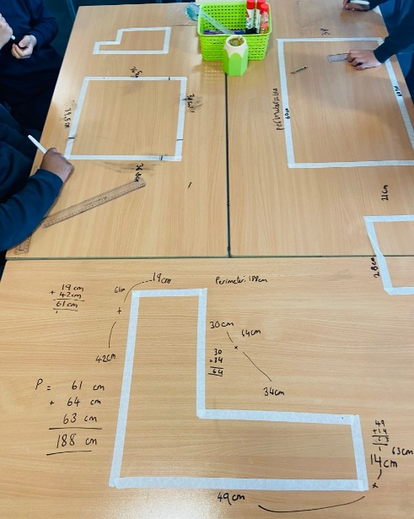
“Maths is one subject which can crush children’s confidence. Implementing low-stake, practical activities can boost children’s confidence, meets the needs of all learners and challenge appropriately” (Boaler, 2015). It is crucial that practical, engaging lessons are incorporated into weekly planning to build confidence, challenge appropriately and allow children to see and learn maths in a variety of ways. They are ideal when:
- Introducing new concepts
- Understanding concepts concretely and pictorially before moving to abstract methods
- Completing shorter maths sessions such as morning work or small interventions.


